Chapter 5, Solution 32.

Calculate i_{x} and v_{o} in the circuit of Fig. 5.70. Find the power dissipated by the 60-kΩ resistor.
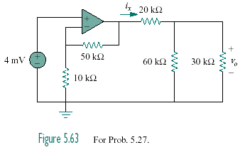

Figure 5.70
For Prob. 5.32.

Solution

Let v_{x} = the voltage at the output of the op amp. The given circuit is a non-inverting amplifier.

(4 mV) = 24 mV

By voltage division,
v_{o} =
i_{x} = 600 nA

p = 204 nW.

